Green Pace Developer: Security Policy Guide Template



Green Pace Secure Development Policy

Contents
Overview 2
Purpose 2
Scope 2
Module Three Milestone 2
Ten Core Security Principles 2
C/C++ Ten Coding Standards 3
Coding Standard 1 4
Coding Standard 2 5
Coding Standard 3 6
Coding Standard 4 7
Coding Standard 5 8
Coding Standard 6 9
Coding Standard 7 10
Coding Standard 8 11
Coding Standard 9 13
Coding Standard 10 14
Defense-in-Depth Illustration 15
Project One 15
1. Revise the C/C++ Standards 15
2. Risk Assessment 15
3. Automated Detection 15
4. Automation 15
5. Summary of Risk Assessments 16
6. Create Policies for Encryption and Triple A 16
7. Map the Principles 17
Audit Controls and Management 18
Enforcement 18
Exceptions Process 18
Distribution 19
Policy Change Control 19
Policy Version History 19
Appendix A Lookups 19
Approved C/C++ Language Acronyms 19

Overview
Software development at Green Pace requires consistent implementation of secure principles to all developed applications. Consistent approaches and methodologies must be maintained through all policies that are uniformly defined, implemented, governed, and maintained over time.

Purpose
This policy defines the core security principles; C/C++ coding standards; authorization, authentication, and auditing standards; and data encryption standards. This article explains the differences between policy, standards, principles, and practices (guidelines and procedure): Understanding the Hierarchy of Principles, Policies, Standards, Procedures, and Guidelines.

Scope
This document applies to all staff that create, deploy, or support custom software at Green Pace.

Module Three Milestone

Ten Core Security Principles
Principles | Write a short paragraph explaining each of the 10 principles of security.
- Validate Input Data | All input should be treated as untrusted until it is checked for type, length, range, format, and business rules. Validating at system boundaries helps prevent malformed data from causing crashes, incorrect results, injection attacks, or unsafe memory use.
- Heed Compiler Warnings | Compiler warnings often identify dangerous patterns such as narrowing conversions, uninitialized variables, unreachable code, and suspicious pointer use. Teams should enable strict warning levels, review warnings during development, and treat unresolved warnings as defects rather than background noise.
- Architect and Design for Security Policies | Security should be built into the design of the system instead of added after implementation. Designers should define trust boundaries, access-control rules, data-handling requirements, and error-handling expectations early so code aligns with approved security policy.
- Keep It Simple | Simple code and simple designs are easier to review, test, and maintain securely than unnecessarily complex solutions. Reducing complexity lowers the chance of hidden logic flaws, unsafe assumptions, and mistakes that attackers can exploit.
- Default Deny | Access should be denied unless a user, process, or request is explicitly allowed. This approach reduces accidental exposure because new features, inputs, or accounts do not automatically gain permissions or behavior that was never intentionally approved.
- Adhere to the Principle of Least Privilege | Each user, process, and component should operate with only the minimum permissions needed to perform its task. Limiting privileges reduces the impact of compromise by preventing a single bug or stolen credential from granting broad system access.
- Sanitize Data Sent to Other Systems | Data that leaves one component and is passed to another system must be cleaned, encoded, or parameterized for that destination. Proper sanitization prevents one system from unintentionally forwarding dangerous content into databases, shells, logs, web pages, or downstream services.
- Practice Defense in Depth | No single safeguard is enough to protect software from failure or attack. Security should rely on multiple layers such as input validation, safe APIs, compiler protections, access controls, logging, and testing so one missed control does not become a total compromise.
- Use Effective Quality Assurance Techniques | Secure software requires disciplined testing and review methods such as peer review, static analysis, dynamic testing, fuzzing, and regression testing. These techniques help teams detect weaknesses early and verify that security controls continue to work as the code changes.
- Adopt a Secure Coding Standard | A secure coding standard gives developers a shared set of approved practices for writing, reviewing, and maintaining code. Using an established standard such as SEI CERT C++ improves consistency, reduces common vulnerabilities, and makes compliance easier to audit.

C/C++ Ten Coding Standards
Complete the coding standards portion of the template according to the Module Three milestone requirements. In Project One, follow the instructions to add a layer of security to the existing coding standards. Please start each standard on a new page, as they may take up more than one page. The first seven coding standards are labeled by category. The last three are blank so you may choose three additional standards. Be sure to label them by category and give them a sequential number for that category. Add compliant and noncompliant sections as needed to each coding standard.

Coding Standard 1

Coding Standard | Label | Name of Standard
Data Type | STD-001-CPP | Use type-safe conversions and avoid unsafe narrowing  C++ data-type mismatches can silently truncate values, reinterpret data incorrectly, or change signedness in ways that break validation logic. Developers must prefer explicit, type-safe conversions and use types whose size and signedness match the intended data to preserve correctness and security.

Noncompliant Code
This example narrows a potentially large integer into a smaller type without checking the range first. If the value is outside the destination range, the program may wrap or truncate the result and make later security checks incorrect.
#include <iostream>
int main() {
int packets = 1000;
short smallCount = packets; // narrowing conversion
std::cout << smallCount << std::endl;
return 0;
}

Compliant Code
This example validates the value before converting it and rejects data that does not fit in the destination type. The explicit range check prevents truncation and makes the conversion safe and predictable.
#include <iostream>
#include <limits>
int main() {
int packets = 1000;
if (packets < std::numeric_limits<short>::min() ||
packets > std::numeric_limits<short>::max()) {
std::cerr << "Value out of range" << std::endl;
return 1;
}
short smallCount = static_cast<short>(packets);
std::cout << smallCount << std::endl;
return 0;
}

Note: Stop here for the milestone. Complete this section for Project One in Module Six.
Principles(s): Validate Input Data – This principle supports the standard by ensuring that incoming data fits within the expected type boundaries, preventing overflow or truncation issues caused by incorrect type assignments.
Use Effective Quality Assurance Techniques – Static analysis and testing validate that correct data types are used consistently, helping detect unsafe conversions or overflow risks early in development.

Threat Level
Severity | Likelihood | Remediation Cost | Priority | Level
High | Medium | Low | High | 4

Automation
Tool | Version | Checker | Description Tool
Ccpcheck | 2.10 | integerOverflow | Detects overflow issues
SonarQube | 10.x | Cpp:S3518 | Detects unsafe type usage
Clang-Tidy | 15.x | clang-analyzer-core | Performs static analysis to catch  type-related bugs and undefined  behavior.

Coding Standard 2

Coding Standard | Label | Name of Standard
Data Value | STD-002-CPP | Validate and constrain all input values

Noncompliant Code
This example accepts user input without validating the range or checking for input errors. If invalid or malicious data is entered, it may cause incorrect logic execution or system instability.
int age;
std::cin >> age;
if (age > 18) {
std::cout << "Access granted";
}

Compliant Code
This example validates the input by checking for input failure and ensuring the value falls within an acceptable range. This prevents invalid data from being processed and enforces safe program behavior.
int age;
std::cin >> age;

if (std::cin.fail() || age < 0 || age > 120) {
std::cerr << "Invalid input";
return 1;
}

if (age >= 18) {
std::cout << "Access granted";
}

Note: Stop here for the milestone. Complete this section for Project One in Module Six.
Principles(s): Validate Input Data
Default deny

Threat Level
Severity | Likelihood | Remediation Cost | Priority | Level
High | High | Low | High | 5

Automation
Tool | Version | Checker | Description Tool
SonarQube | 10.x | Cpp:S5131 | Detects missing validation and unsafe input handling
CppCheck | 2.10 | invalidInput | Flags unvalidated input usage
OWASP ZAP | 2.14 | Input Validation Scan | Dynamically tests application endpoints for improper validation

Coding Standard 3

Coding Standard | Label | Name of Standard
String Correctness | STD-003-CPP | Prevent unsafe string operations

Noncompliant Code
This example uses unsafe string functions that can write beyond allocated memory, leading to buffer overflows and potential security vulnerabilities.
char buffer[10];
strcpy(buffer, "This string is too long");

Compliant Code
This example uses std::string, which automatically manages memory and prevents overflow issues, ensuring safer string handling.
#include <string>

std::string safeString = "This string is safe";

Note: Stop here for the milestone. Complete this section for Project One in Module Six.
Principles(s): Sanitize Data Sent to Other Systems – Prevents unsafe string handling such as buffer overflows or injection risks.
Defense in Depth – Using safe string libraries (like std::string) adds an additional layer of protection against memory-related vulnerabilities.

Threat Level
Severity | Likelihood | Remediation Cost | Priority | Level
High | High | Medium | High | 5

Automation
Tool | Version | Checker | Description Tool
AddressSanitizer | GCC 13 . Clang 15 | Buffer-overflow | Detects runtime memory and buffer overflow issues
CppCheck | 2.10 | bufferAccessOutOfBounds | Identifies unsafe string operations
SonarQube | 10.x | Cpp:S2259 | Flags unsafe string manipulation patterns

Coding Standard 4

Coding Standard | Label | Name of Standard
SQL Injection | STD-004-CPP | Prevent SQL injection using parameterized queries

Noncompliant Code
This example directly concatenates user input into a SQL query, allowing attackers to manipulate the query and potentially access or modify unauthorized data.
std::string query = "SELECT * FROM users WHERE name = '" + userInput + "'";

Compliant Code
This example uses parameterized queries, which separate user input from SQL commands, preventing malicious input from altering query structure.
// Example using parameterized query (pseudo-code)
prepare("SELECT * FROM users WHERE name = ?");
bind(userInput);
execute();

Note: Stop here for the milestone. Complete this section for Project One in Module Six.
Principles(s): Validate Input Data – Ensures user input is validated before being used in queries.
Least Privilege – Limits database access permissions to reduce the impact of a successful injection attack.

Threat Level
Severity | Likelihood | Remediation Cost | Priority | Level
High | High | Medium | High | 5

Automation
Tool | Version | Checker | Description Tool
OWASP ZAP | 2.14 | SQL Injection Scan | Detects SQL injection vulnerabilities dynamically
SonarQube | 10.x | Cpp:S3649 | Identifies unsafe query construction
Burp Suite | 2024.x | Active Scanner | Tests endpoints for injection vulnerabilities

Coding Standard 5

Coding Standard | Label | Name of Standard
Memory Protection | STD-005-CPP | Prevent buffer overflows and memory misuse

Noncompliant Code
This example reads input into a fixed-size buffer without bounds checking, which can lead to buffer overflow and memory corruption.
char input[10];
std::cin >> input;

Compliant Code
This example uses safer input handling with std::string, which dynamically resizes and prevents memory overflow vulnerabilities.
std::string input;
std::getline(std::cin, input);

Note: Stop here for the milestone. Complete this section for Project One in Module Six.
Principles(s): Defense in Depth – Multiple safeguards such as smart pointers prevent memory misuse.
Adopt a Secure Coding Standard – Enforces safe memory management practices like RAII.

Threat Level
Severity | Likelihood | Remediation Cost | Priority | Level
High | Medium | Medium | High | 4

Automation
Tool | Version | Checker | Description Tool
Valgrind | 3.21 | Memcheck | Detects memory leaks and invalid memory usage
AddressSanitizer | GCC 13 | Memory-leak | Identifies runtime memory errors
Cppcheck | 2.10 | Memleak | Flags memory leaks in static analysis

Coding Standard 6

Coding Standard | Label | Name of Standard
Assertions | STD-006-CPP | Use assertions for debugging, not runtime validation

Noncompliant Code
This example relies on assertions for input validation. Assertions can be disabled in production, making them unreliable for enforcing security checks.

assert(userInput != nullptr);

Compliant Code
This example replaces assertions with proper runtime validation using conditional checks, ensuring that invalid input is always handled regardless of build configuration.
if (userInput == nullptr) {
std::cerr << "Invalid input";
return 1;
}

Note: Stop here for the milestone. Complete this section for Project One in Module Six.
Principles(s): Use Effective QA Techniques – Assertions validate assumptions during development and testing.
Keep It Simple – Ensures logic remains clear and predictable.

Threat Level
Severity | Likelihood | Remediation Cost | Priority | Level
Medium | Medium | Low | Medium | 3

Automation
Tool | Version | Checker | Description Tool
Cppcheck | 2.10 | assertWithSideEffect | Detects improper assertion usage
SonarQube | 10.x | Cpp:S5960 | Identifies misuse of assertions

Coding Standard 7

Coding Standard | Label | Name of Standard
Exceptions | STD-007-CPP | Handle exceptions safely and consistently

Noncompliant Code
This example throws an exception without handling it, which may crash the program or expose sensitive error details.
throw std::runtime_error("Error occurred");

Compliant Code
This example uses try-catch blocks to properly handle exceptions, ensuring controlled error handling and preventing system crashes.
try {
// risky code
} catch (const std::exception& e) {
std::cerr << "Handled error: " << e.what();
}

Note: Stop here for the milestone. Complete this section for Project One in Module Six.
Principles(s): Defense in Depth – Proper exception handling prevents system crashes and information leaks.
QA Techniques – Testing ensures exceptions are handled correctly.

Threat Level
Severity | Likelihood | Remediation Cost | Priority | Level
Medium | Medium | Low | Medium | 4

Automation
Tool | Version | Checker | Description Tool
SonarQube | 10.x | Cpp:S2737 | Detects improper exception handling
Cppcheck | 2.10 | ExceptionHandling | Flags unsafe exception usage

Coding Standard 8

Coding Standard | Label | Name of Standard
Input Sanitization | STD-008-CPP | Sanitize all external inputs

Noncompliant Code
This example outputs user input directly without validation or sanitization, which may allow malicious content such as scripts or harmful data.
std::cout << userInput;

Compliant Code
This example checks and sanitizes user input before use, preventing harmful or unexpected data from being processed.
// sanitize input (example)
if (userInput.find("<script>") != std::string::npos) {
std::cerr << "Invalid input";
}

Note: Stop here for the milestone. Complete this section for Project One in Module Six.
Principles(s): Validate Input Data – This principle maps directly to input sanitization because the application must verify that incoming data conforms to expected formats, lengths, and character rules before using it. Sanitization is one of the key ways validation is enforced.
Sanitize Data Sent to Other Systems – This principle directly supports the standard because unsafe data should never be forwarded to databases, APIs, logs, or other internal services without first being cleaned. Sanitization prevents one insecure input from becoming a larger system-wide vulnerability.
Practice Defense in Depth – Input sanitization adds another layer of protection even when other controls such as authentication or parameterized APIs are already in place. If one defense fails, sanitized input reduces the chance of compromise.

Threat Level
Severity | Likelihood | Remediation Cost | Priority | Level
High | High | Low | High | 5

Automation
Tool | Version | Checker | Description Tool
SonarQube | 10.x | Cpp:S5131 | Detects unsafe handling of untrusted input and highlights places where validation or sanitization is missing before data is used
Cppcheck | 2.10 | Uninitvar/ invalidFunctionArg | Helps identify dangerous input handling patterns and improper use of values that may not have been safely validated before processing
OWASP ZAP | 2.14 | Active Scan / Input Validation Testing | Dynamically tests application application endpoints with malformed or hostile input to identify weak sanitization and validation controls
Clang-Tidy | 15.x | Clang-analyzer-security.* | Performs static analysis focused on risky coding patterns that may expose insecure handling of external input

Coding Standard 9

Coding Standard | Label | Name of Standard
Logging and Monitoring | STD-009-CPP | Implement secure logging practices

Noncompliant Code
This example logs sensitive information such as passwords, which can lead to data exposure if logs are accessed by unauthorized users.
std::cout << "Password: " << password;

Compliant Code
This example logs only necessary information while avoiding sensitive data, ensuring logs remain useful without compromising security.
std::cout << "User login attempt recorded";

Note: Stop here for the milestone. Complete this section for Project One in Module Six.
Principles(s): Practice Defense in Depth – Logging and monitoring act as a secondary layer of defense by detecting malicious activity that bypasses preventive controls. Even if an attack occurs, logs provide visibility and allow for rapid response.
Use Effective Quality Assurance Techniques – Logging mechanisms must be tested to ensure they correctly capture important events and do not expose sensitive information. QA ensures logs are both useful and secure.
Adopt a Secure Coding Standard – Establishing consistent logging practices ensures developers know what events to log and how to securely handle log data across all systems.

Threat Level
Severity | Likelihood | Remediation Cost | Priority | Level
Medium | High | Low | Medium | 3

Automation
Tool | Version | Checker | Description Tool
SonarQube | 10.x | Cpp:S5757 | Identifies insecure logging practices, such as logging sensitive information or improper log handling
Splunk Enterprise | 9.x | Log Monitoring Rules | Aggregates logs and detects suspicious activity such as failed logins or abnormal access patterns
Elastic Stack (ELK) | 8.x | Detection Engine | Collects and analyzes logs for anomalies, enabling real-time monitoring and alerting
Semgrep | 1.x | Logging Security Rules | Detects unsafe logging patterns in source code, including exposure of credentials or tokens

Coding Standard 10

Coding Standard | Label | Name of Standard
Least Privilege | STD-010-CPP | Enforce least privilege access

Noncompliant Code
This example runs with excessive permissions, increasing the risk of damage if the system is compromised.
// Running application as admin unnecessarily

Compliant Code
This example ensures the application runs with minimal required permissions, limiting the impact of potential security breaches.
// Run with limited user permissions

Note: Stop here for the milestone. Complete this section for Project One in Module Six.
Principles(s): Adhere to the Principle of Least Privilege – This principle directly defines the standard by requiring that access rights be restricted to only what is necessary. It minimizes risk by reducing unnecessary permissions.
Default Deny – Systems should deny access by default unless explicitly granted. This ensures that no user or process has unintended privileges.
Practice Defense in Depth – Limiting access adds another layer of protection, reducing the impact of other vulnerabilities or compromised credentials.

Threat Level
Severity | Likelihood | Remediation Cost | Priority | Level
High | Medium | Low | High | 4

Automation
Tool | Version | Checker | Description Tool
SonarQube | 10.x | Cpp:S2068 | Detects hard-coded credentials and insecure access patterns that violate least privilege practices
OWASP ZAP | 2.14 | Access Control Testing | Tests for broken access control and privilege escalation vulnerabilities
Microsoft Active Directory | Windows Server 2022 | Group Policy Analyzer | Enforces and audits user roles and permissions across systems
OpenSCAP | 1.3x | Security Compliance Rules | Evaluates system configurations to ensure least privilege policies are enforced

Defense-in-Depth Illustration
This illustration provides a visual representation of the defense-in-depth best practice of layered security.



Project One
There are seven steps outlined below that align with the elements you will be graded on in the accompanying rubric. When you complete these steps, you will have finished the security policy.

Revise the C/C++ Standards
You completed one of these tables for each of your standards in the Module Three milestone. In Project One, add revisions to improve the explanation and examples as needed. Add rows to accommodate additional examples of compliant and noncompliant code. Coding standards begin on the security policy.

Risk Assessment
Complete this section on the coding standards tables. Enter high, medium, or low for each of the headers, then rate it overall using a scale from 1 to 5, 5 being the greatest threat. You will address each of the seven policy standards. Fill in the columns of severity, likelihood, remediation cost, priority, and level using the values provided in the appendix.

Automated Detection
Complete this section of each table on the coding standards to show the tools that may be used to detect issues. Provide the tool name, version, checker, and description. List one or more tools that can automatically detect this issue and its version number, name of the rule or check (preferably with link), and any relevant comments or description—if any. This table ties to a specific C++ coding standard.

Automation
Provide a written explanation using the image provided.


Automation will be used for the enforcement of and compliance to the standards defined in this policy. Green Pace already has a well-established DevOps process and infrastructure. Define guidance on where and how to modify the existing DevOps process to automate enforcement of the standards in this policy. Use the DevSecOps diagram and provide an explanation using that diagram as context.

Automation will be integrated throughout the DevSecOps pipeline to ensure continuous enforcement of secure coding standards. During the “Create” phase, developers will use IDE plugins and static analysis tools such as Cppcheck and SonarQube to identify vulnerabilities in real time. In the “Verify” phase, automated security testing tools, including static application security testing (SAST) and dynamic application security testing (DAST) tools like OWASP ZAP, will scan the application for vulnerabilities such as injection flaws and improper input validation.
In the pre-production and release phases, additional testing such as fuzz testing and integration testing will validate system behavior under unexpected conditions. Monitoring tools such as Splunk and Elastic Stack will be used in the “Detect” phase to identify suspicious activity and potential threats in real time. This continuous automation ensures that security is enforced at every stage of development, supporting a defense-in-depth strategy and reducing the risk of vulnerabilities reaching production.

Summary of Risk Assessments
Consolidate all risk assessments into one table including both coding and systems standards, ordered by standard number.

Rule | Severity | Likelihood | Remediation Cost | Priority | Level
STD-001-CPP | High | Unlikely | Medium | High | 2
STD-002-CPP | High | High | Low | High | 5
STD-003-CPP | High | High | Medium | High | 5
STD-004-CPP | High | High | Medium | High | 5
STD-005-CPP | High | Medium | Medium | High | 4
STD-006-CPP | Medium | Medium | Low | Medium | 3
STD-007-CPP | High | Medium | Medium | High | 4
STD-008-CPP | High | High | Low | High | 5
STD-009-CPP | Medium | Medium | Low | Medium | 3
STD-010-CPP | High | Medium | Medium | High | 4

Create Policies for Encryption and Triple A
Include all three types of encryption (in flight, at rest, and in use) and each of the three elements of the Triple-A framework using the tables provided.
  - Explain each type of encryption, how it is used, and why and when the policy applies.
  - Explain each type of Triple-A framework strategy, how it is used, and why and when the policy applies.

Write policies for each and explain what it is, how it should be applied in practice, and why it should be used.

- Encryption | Explain what it is and how and why the policy applies.
Encryption at rest | Data stored in databases, files, and backups must be encrypted using strong encryption algorithms such as AES-256. This policy applies whenever sensitive data is stored to protect it from unauthorized access in the event of a breach or physical compromise.
Encryption in flight | All data transmitted between systems must be encrypted using secure protocols such as TLS. This ensures that sensitive information cannot be intercepted during transmission, protecting against man-in-the-middle attacks.
Encryption in use | Sensitive data must be protected while being processed in memory by minimizing exposure time and using secure handling techniques. This reduces the risk of memory-based attacks and unauthorized access during execution.

- Triple-A Framework* | Explain what it is and how and why the policy applies.
Authentication | Authentication verifies the identity of users before granting access to the system. This includes secure login processes such as password hashing, multi-factor authentication, and session management to ensure only authorized users can access the system.
Authorization | Authorization determines what actions a user can perform after authentication. Role-based access control (RBAC) is used to ensure users only have access to the resources necessary for their role, enforcing the principle of least privilege.
Accounting | Accounting tracks user activity within the system, including login attempts, data access, and system changes. Logs are used for auditing and monitoring to detect suspicious behavior and support incident response.

*Use this checklist for the Triple A to be sure you include these elements in your policy:

- User logins
- Changes to the database
- Addition of new users
- User level of access
- Files accessed by users

Map the Principles
Map the principles to each of the standards, and provide a justification for the connection between the two. In the Module Three milestone, you added definitions for each of the 10 principles provided. Now it’s time to connect the standards to principles to show how they are supported by principles. You may have more than one principle for each standard, and the principles may be used more than once. Principles are numbered 1 through 10. You will list the number or numbers that apply to each standard, then explain how each of these principles supports the standard. This exercise demonstrates that you have based your security policy on widely accepted principles. Linking principles to standards is a best practice.

NOTE: Green Pace has already successfully implemented the following:

- Operating system logs
- Firewall logs
- Anti-malware logs
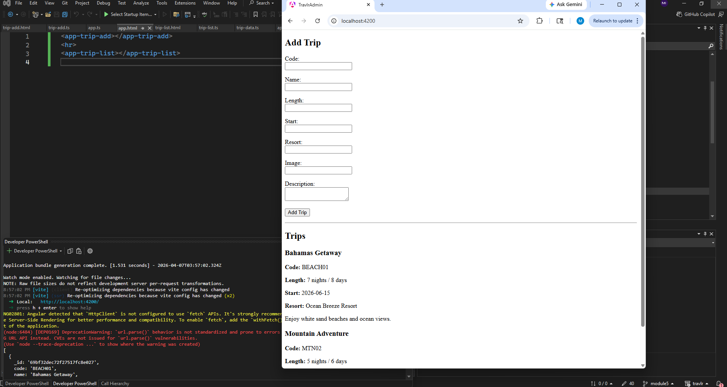
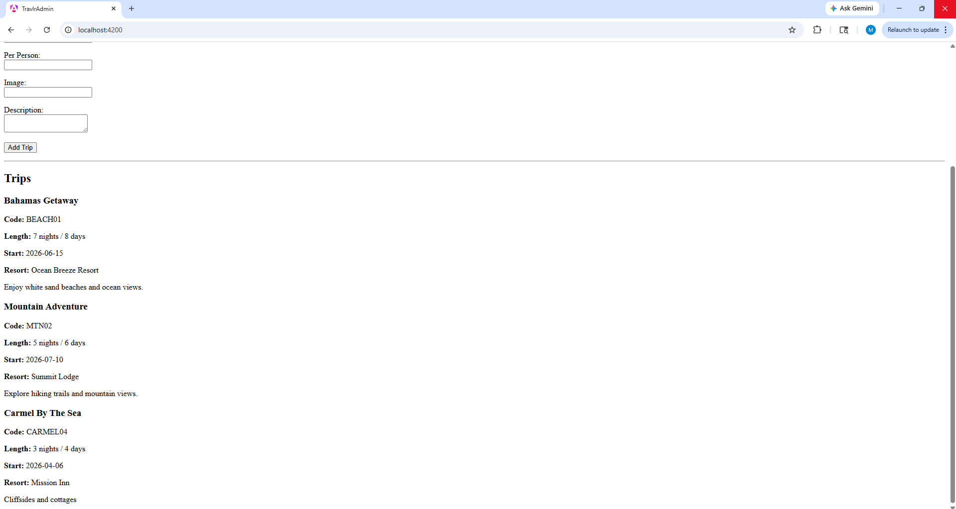
The only item you must complete beyond this point is the Policy Version History table.
The Angular project structure is different from the Express-based customer-facing application because it is built as a client-side single-page application (SPA) rather than a server-rendered application. The Express application uses routes and Handlebars templates to generate pages on the server and send them to the browser, while the Angular application is organized into components, services, and modules that run entirely on the client side. Angular components control different parts of the user interface, and services are used to communicate with the backend API. This structure allows for better separation of concerns and makes the application easier to maintain and scale.
The SPA provides additional functionality compared to a traditional web application by allowing the interface to update dynamically without reloading the page. For example, when an administrator creates, edits, or updates a trip, the changes are reflected immediately in the interface without navigating away or refreshing the page. This results in a smoother and more responsive user experience. Angular also provides built-in features such as form validation, routing, and two-way data binding, which improve usability and efficiency when interacting with the application.
The testing process involved verifying that the Angular application correctly communicates with the backend API. This was done by testing GET and PUT requests to ensure that trip data could be retrieved and updated in the MongoDB database. Tools such as Postman were used to confirm that the API endpoints returned the correct responses, while the user interface was tested by performing actions such as editing and updating trips to ensure the changes were properly reflected. This confirmed that the front end and backend were fully integrated and functioning as expected.

Audit Controls and Management
Every software development effort must be able to provide evidence of compliance for each software deployed into any Green Pace managed environment.

Evidence will include the following:

- Code compliance to standards
- Well-documented access-control strategies, with sampled evidence of compliance
- Well-documented data-control standards defining the expected security posture of data at rest, in flight, and in use
- Historical evidence of sustained practice (emails, logs, audits, meeting notes)

Enforcement
The office of the chief information security officer (OCISO) will enforce awareness and compliance of this policy, producing reports for the risk management committee (RMC) to review monthly. Every system deployed in any environment operated by Green Pace is expected to be in compliance with this policy at all times.

Staff members, consultants, or employees found in violation of this policy will be subject to disciplinary action, up to and including termination.

Exceptions Process
Any exception to the standards in this policy must be requested in writing with the following information:

- Business or technical rationale
- Risk impact analysis
- Risk mitigation analysis
- Plan to come into compliance
- Date for when the plan to come into compliance will be completed

Approval for any exception must be granted by chief information officer (CIO) and the chief information security officer (CISO) or their appointed delegates of officer level.

Exceptions will remain on file with the office of the CISO, which will administer and govern compliance.

Distribution
This policy is to be distributed to all Green Pace IT staff annually. All IT staff will need to certify acceptance and awareness of this policy annually.

Policy Change Control
This policy will be automatically reviewed annually, no later than 365 days from the last revision date. Further, it will be reviewed in response to regulatory or compliance changes, and on demand as determined by the OCISO.

Policy Version History

Version | Date | Description | Edited By | Approved By
1.0 | 08/05/2020 | Initial Template | David Buksbaum
1.1 | 04/10/2026 | Completed security policy | Jeremia Lim
[Insert text.] | [Insert text.] | [Insert text.] | [Insert text.] | [Insert text.]

Appendix A Lookups

Approved C/C++ Language Acronyms

Language | Acronym
C++ | CPP
C | CLG
Java | JAV

